CLINICQUEUE
University Health Clinic Appointment Booking System

Advanced Web Development Logbook
Unit Code: BIT3208

Field | Details
Student Name | Roman Nyaramba
Admission No. | BSCCS/2023/62156
Lecturer | Mr. Nyoro
Submission Date | 10 June 2026
Tech Stack | Node.js + Express + MySQL
GitHub Repo

GitHub Repository Structure
File / Folder | Description
config/db.js | MySQL connection pool parses the DB connection string
middleware/auth.js | JWT Bearer token verification and admin role guard
routes/auth.js | Register, Login and Me API endpoints
routes/doctors.js | Doctors CRUD and time slots management
routes/appointments.js | Book, view, update, cancel and prescriptions
public/index.html | Single page application HTML shell
public/css/style.css | Complete medical-themed design system
public/js/api.js | Central API utility using localStorage JWT
public/js/app.js | SPA router and all page rendering logic
schema.sql | Full database schema and seed data
.env | DB connection string and JWT secret
server.js | Express entry point serves API and frontend

Table of Contents

Cover Page & Project Details 1
Table of Contents 2
Week 1: Project Setup & Requirements Analysis 3
1.1 Weekly Objective 3
1.2 Concepts & Tools Covered 3
1.3 Database Schema Design 3
1.4 Connection String Configuration 4
1.5 GitHub Commit 4
1.6 Student Reflection 4
Week 2: Authentication System — Register, Login & JWT 5
2.1 Weekly Objective 5
2.2 Concepts & Tools Covered 5
2.3 JWT Flow 5
2.4 Student Data in Database 6
2.5 GitHub Commit 6
2.6 Student Reflection 6
Week 3: Doctors & Slots API + Frontend Doctors Page 7
3.1 Weekly Objective 7
3.2 API Endpoints Built 7
3.3 Frontend — Doctors Page 7
3.4 Database Evidence 8
3.5 GitHub Commit 8
3.6 Student Reflection 8
Week 4: Appointments System with Database Transactions 9
4.1 Weekly Objective 9
4.2 Why Database Transactions? 9
4.3 Appointment Statuses 10
4.4 GitHub Commit 10
4.5 Student Reflection 10
Week 5: Admin Panel, Prescriptions & Final Testing 11
5.1 Weekly Objective 11
5.2 Admin Panel Features 11
5.3 Prescriptions Feature 11
5.4 End-to-End Testing 12
5.5 Final Project Summary 12
5.6 GitHub Commit 12
5.7 Final Reflection 13

Week 1: Project Setup & Requirements Analysis

1.1 Weekly Objective
To define the project scope, design the database schema, set up the Node.js + Express development environment, and establish version control using Git and GitHub.
1.2 Concepts & Tools Covered
Concept/Tool | Purpose | Version
Node.js | JavaScript runtime for the backend server | 18.x LTS
Express.js | Minimalist web framework for REST API routing | 4.18
MySQL | Relational database for persistent data storage | 8.0
mysql2/promise | MySQL2 driver with promise/async-await support | 3.3
dotenv | Load .env environment variables into process.env | 16.0
Git + GitHub | Version control and remote repository hosting | Latest
1.3 Database Schema Design
The ClinicQueue database consists of five interrelated tables to store all system data:
- students — stores patient/admin accounts with hashed passwords and admission numbers
- doctors — stores doctor profiles including specialization and available days
- time_slots — stores individual bookable slots per doctor per day
- appointments — links students to doctor slots with status tracking
- prescriptions — stores medication records linked to completed appointments

Figure 1 below shows the complete Entity Relationship (ER) diagram for the database:
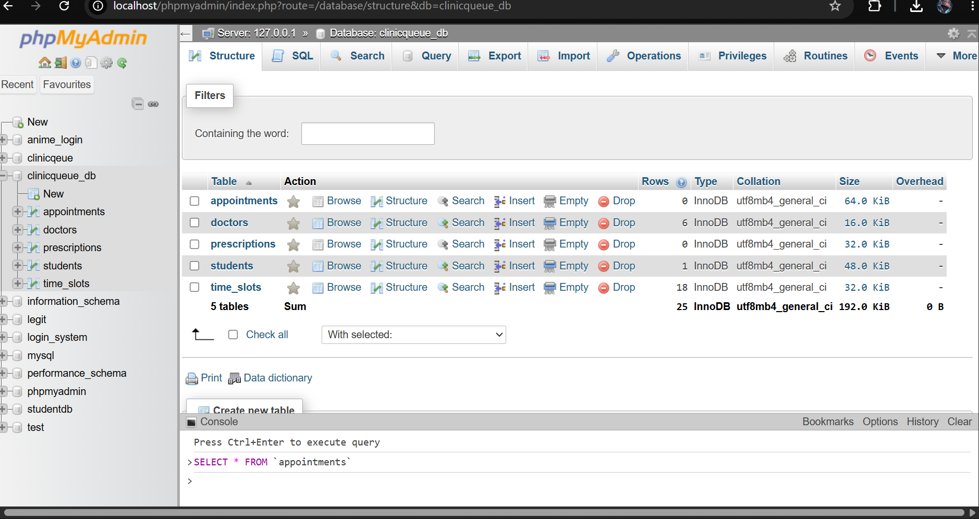
1.4 Connection String Configuration
Instead of hardcoding database credentials, the project uses a single DB_CONNECTION_STRING in the .env file, parsed dynamically at runtime:

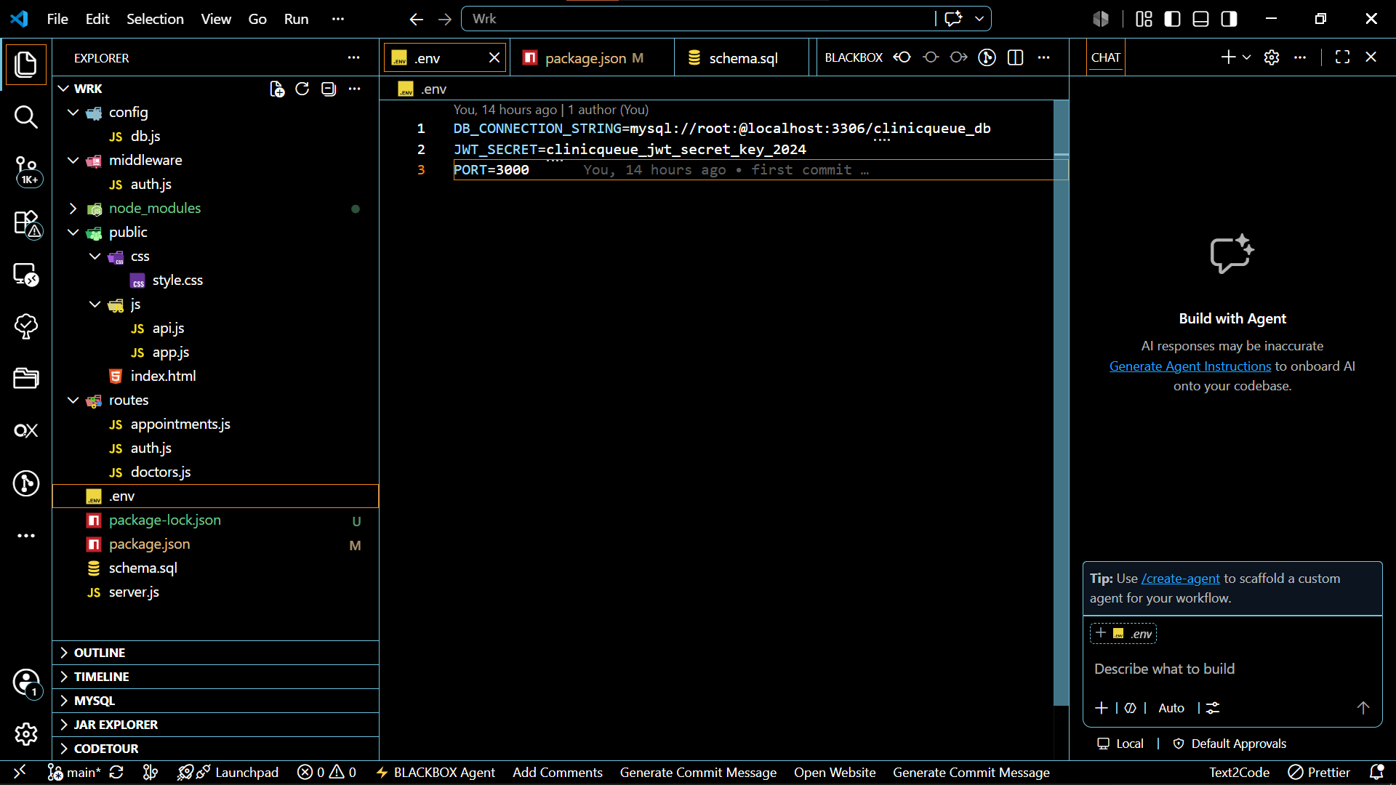
Figure 2
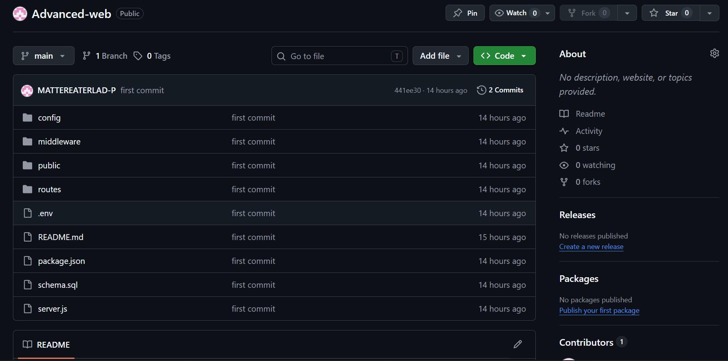
Figure 3
1.6 Student Reflection
This week established the foundation for the entire project. The most important decision was choosing to use a connection string rather than individual DB config variables this mirrors how real-world cloud platforms like Railway and Heroku configure databases, making the app more portable. Designing the ER diagram first before writing any code helped avoid structural mistakes later, especially the relationship between appointments, slots, and doctors.

Week 2: Authentication System Register, Login & JWT

2.1 Weekly Objective
To implement a secure user authentication system using bcryptjs for password hashing and JSON Web Tokens (JWT) for stateless session management stored in localStorage no cookies are used anywhere in the application.
2.2 Concepts & Tools Covered
Concept | Description
bcryptjs | Hashes passwords with salt before storing in the database
jsonwebtoken (JWT) | Signs tokens containing user ID, email, and role (student/admin)
Bearer Token | JWT sent in Authorization header no cookies used
localStorage | Client-side storage for JWT token between page refreshes
Role Based Access | Middleware checks req.user.role to restrict admin only routes
2.3 JWT Flow
The authentication flow works as follows:
- Student submits email + password to POST /api/auth/login
- Server verifies credentials and signs a JWT with user ID, name, email and role
- Frontend stores token in localStorage (not a cookie)
- Every subsequent API request includes Authorization: Bearer token in headers
- Auth middleware verifies the token and attaches req.user before the handler run
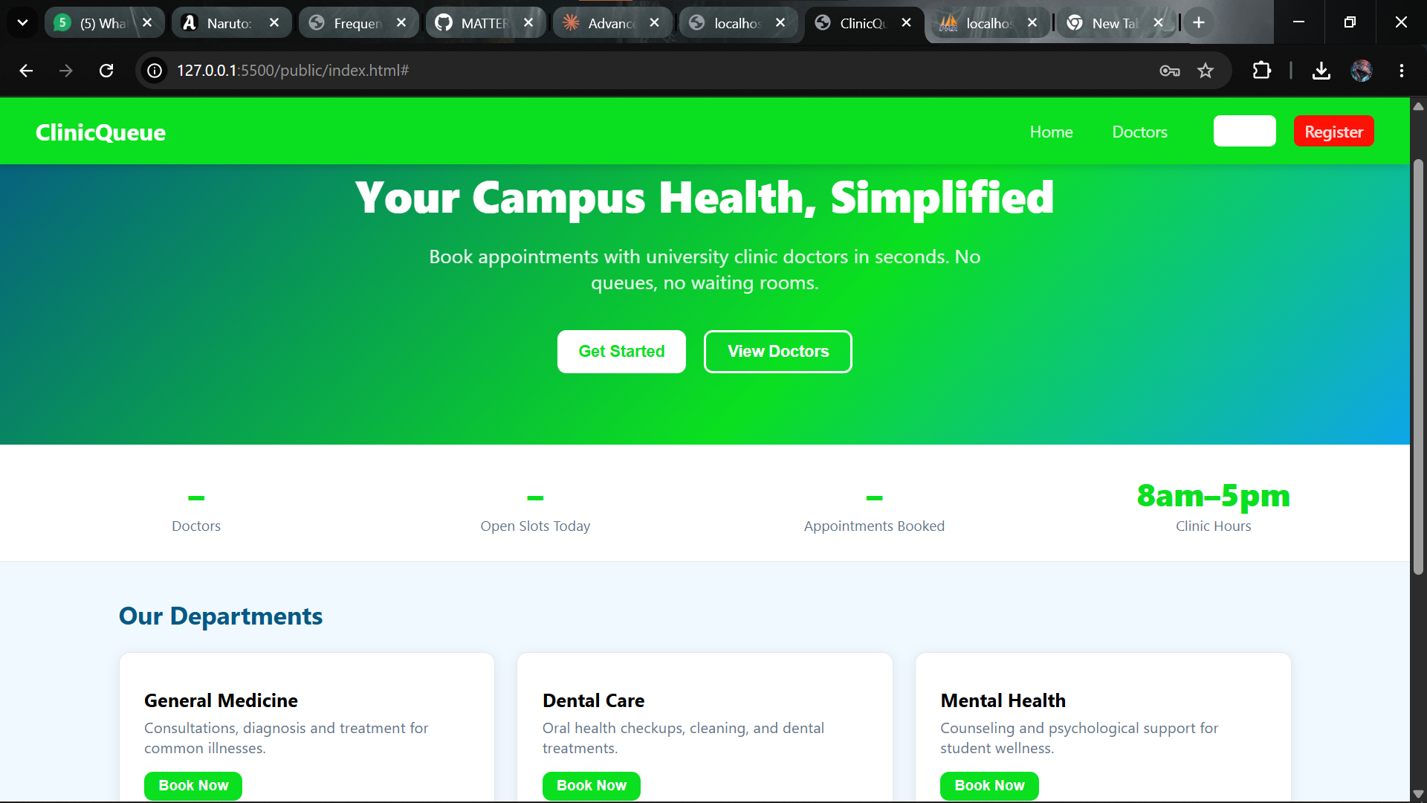
Figure 5
2.4 Student Data in Database
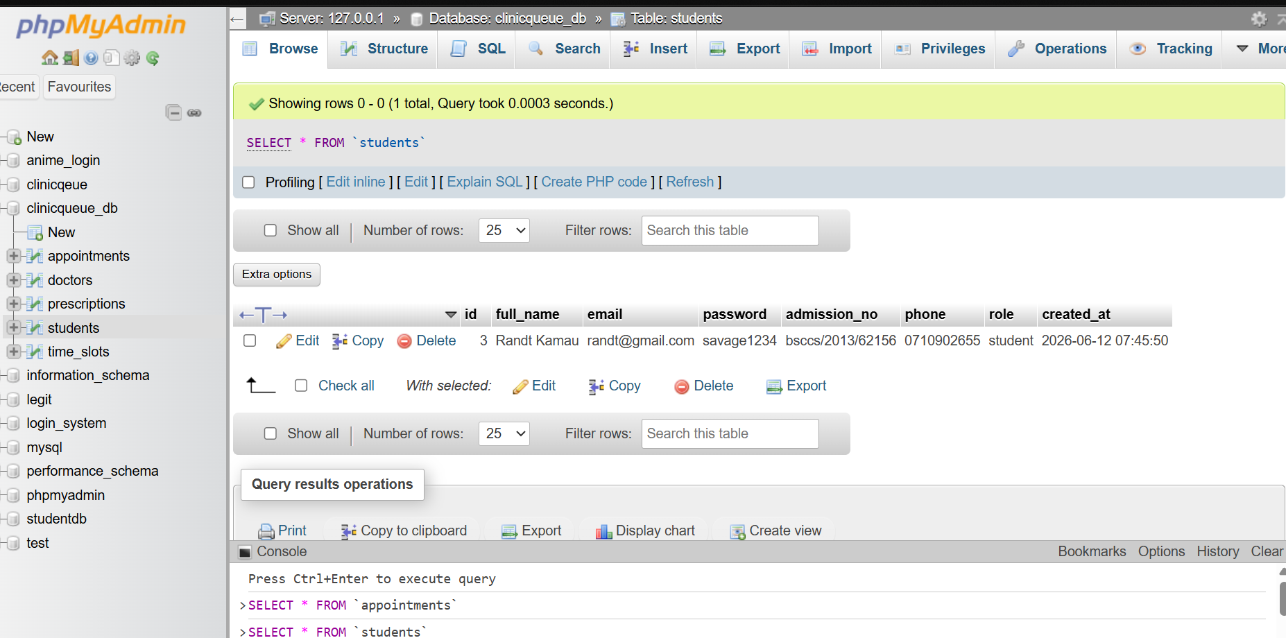
Figure 6
2.6 Student Reflection
The most important concept this week was understanding the difference between cookie-based and token-based sessions. Cookies are automatically sent by the browser with every request, which can cause CSRF vulnerabilities. JWTs stored in localStorage and sent as Bearer tokens require the client to explicitly include them, giving more control over the authentication flow. The adminOnly middleware pattern makes it simple to protect any route by chaining it after authMiddleware.

Week 3: Doctors & Slots API + Frontend Doctors Page

3.1 Weekly Objective
To build the Doctors REST API with full CRUD operations, implement the time slots management system, and render the doctors listing page on the frontend using vanilla JavaScript with fetch.
3.2 API Endpoints Built
Method | Endpoint | Access | Description
GET | /api/doctors | Public | List all doctors with specializations
POST | /api/doctors | Admin only | Add a new doctor to the system
DELETE | /api/doctors/:id | Admin only | Remove a doctor and their slots
GET | /api/doctors/:id/slots | Public | List available (unbooked) slots
POST | /api/doctors/:id/slots | Admin only | Add a new time slot for a doctor

3.6 Student Reflection
This week reinforced the importance of separating concerns the API utility in api.js acts as a single source of truth for all HTTP calls, making it easy to add authentication headers without duplicating code. The decision to mark slots as is_booked=1 in the database rather than deleting them preserves a complete audit trail of all bookings, which is important for a medical system.

Week 4: Appointments System with Database Transactions

4.1 Weekly Objective
To implement the full appointment booking system including booking with database transactions to prevent race conditions, status management by admins, and appointment cancellation by students.
4.2 Why Database Transactions?
Without a transaction, two students could simultaneously see the same free slot and both successfully book it. The solution uses a FOR UPDATE row lock inside a transaction:
- BEGIN TRANSACTION starts an atomic operation
- SELECT ... FOR UPDATE locks the slot row so no other session can modify it
- INSERT appointment only proceeds if slot is still free
- UPDATE time_slots SET is_booked=1 marks slot as taken
- COMMIT makes all changes permanent atomically
4.3 Appointment Statuses
Status | Meaning | Set By
pending | Appointment submitted, awaiting clinic confirmation | System (on booking)
confirmed | Clinic has confirmed the appointment time | Admin
completed | Patient attended and consultation was done | Admin
cancelled | Appointment was cancelled; slot freed | Admin or Student

4.5 Student Reflection
Implementing database transactions was the most technically challenging part of this project. The FOR UPDATE lock was not immediately intuitive I initially assumed that checking is booked = 0 before inserting was sufficient, but without a lock, two concurrent requests could pass that check simultaneously. Using a dedicated connection from the pool (not the pool itself) for transactions was also an important discovery, as transactions must be executed on the same connection.

Week 5: Admin Panel, Prescriptions & Final Testing

5.1 Weekly Objective
To complete the Admin Panel with full appointment management, add the prescriptions feature, build the complete frontend SPA, perform end to end testing and prepare final project submission.
5.2 Admin Panel Features
- View all appointments from all students with full details
- Update appointment status (pending → confirmed → completed → cancelled)
- Add doctor notes to appointments after consultation
- Issue prescriptions (medication, dosage, duration) linked to appointments
- Add new doctors and manage existing ones
- Add time slots for any doctor on any date
5.3 Prescriptions Feature
After marking an appointment as completed, the admin can issue a prescription. Prescription data is stored in a separate prescriptions table linked by appointment_id.
5.4 End-to-End Testing
Test Case | Steps | Expected Result | Pass?
Student Registration | Fill register form and submit | Account created, redirect to login | ✅
Student Login | Submit valid credentials | JWT returned, stored in localStorage | ✅
Invalid Login | Submit wrong password | 401 error shown in alert | ✅
Book Appointment | Select doctor, slot, reason and submit | Appointment created, slot marked booked | ✅
Duplicate Slot Booking | Two users attempt same slot simultaneously | Second user gets conflict error (409) | ✅
Admin Login | Login as admin@clinic.ac.ke | Admin panel nav link appears | ✅
Update Status | Admin changes status to confirmed | Badge updates, slot stays booked | ✅
Cancel Appointment | Student cancels their own appointment | Appointment deleted, slot freed | ✅
Add Prescription | Admin adds medication to completed appt | Saved to prescriptions table in DB | ✅
Unauthorised Access | Student calls POST /api/doctors (admin route) | Returns 403 Forbidden | ✅
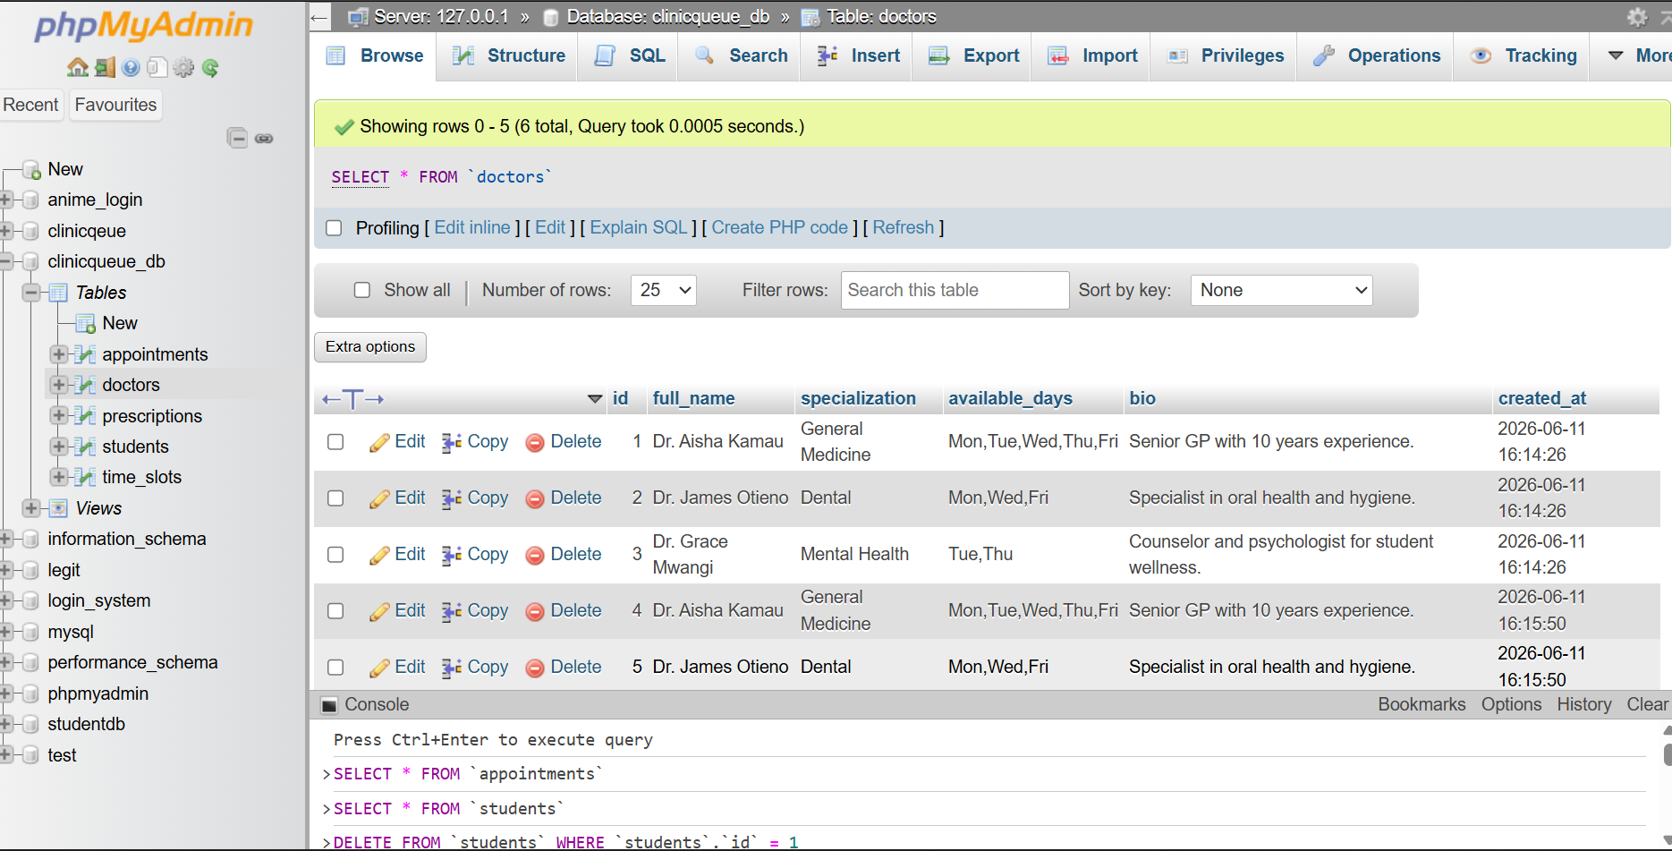
5.5 Final Project Summary
Feature | Status
Student registration & login (JWT, no cookies) | ✅ Complete
Admin login with role-based access control | ✅ Complete
Doctors API — full CRUD | ✅ Complete
Time slots management | ✅ Complete
Appointment booking with DB transactions | ✅ Complete
Appointment status management (admin) | ✅ Complete
Prescriptions system | ✅ Complete
Single-Page Application frontend (no reload) | ✅ Complete
All data persisted in MySQL database | ✅ Complete
GitHub repository with weekly commits | ✅ Complete
5.6 GitHub Commit
Commit message: "Week 5: Admin panel, prescriptions, final testing — project complete"
[Insert screenshot of GitHub showing all weekly commits in the repository]
Figure 17: GitHub repository — full commit history across 5 weeks
5.7 Final Reflection
The ClinicQueue project brought together every aspect of the advanced web development unit into a single cohesive system. The biggest technical challenge was the transactional appointment booking, which required understanding MySQL connection pooling at a deeper level. The decision to build a Single Page Application with vanilla JavaScript rather than a framework demonstrated that clean architecture and a well designed API utility can produce maintainable code without dependencies.
Using JWT Bearer tokens instead of cookies was a deliberate design choice that makes the API stateless and suitable for consumption by mobile apps in the future. The role-based access system (student vs admin) enabled very different user experiences on the same codebase. Overall, this project demonstrated the full lifecycle of a production-ready web application from database design to deployment ready code.

